11 B2249 224 224 **Super Student Mason Sangalang**

**UPCOMING EVENTS**

**November 16th- Our first field trip!!**

**We will be seeing How the Grinch Stole Christmas** **at the Old Globe**

**with First and Second Grade!**

**Permission Slips coming home today**

**Super Student Eden Hallak**

**SHARING**

**October 11**

Please practice guiding questions with your student

Gavin, Elise, Mason, Scarlet, Ally

**Memory Words Please review daily with your student**

**Red, orange, yellow, green, blue, purple, brown, black, see, I, like, to**

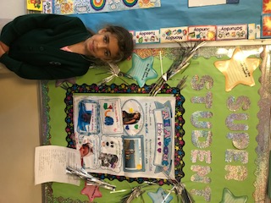

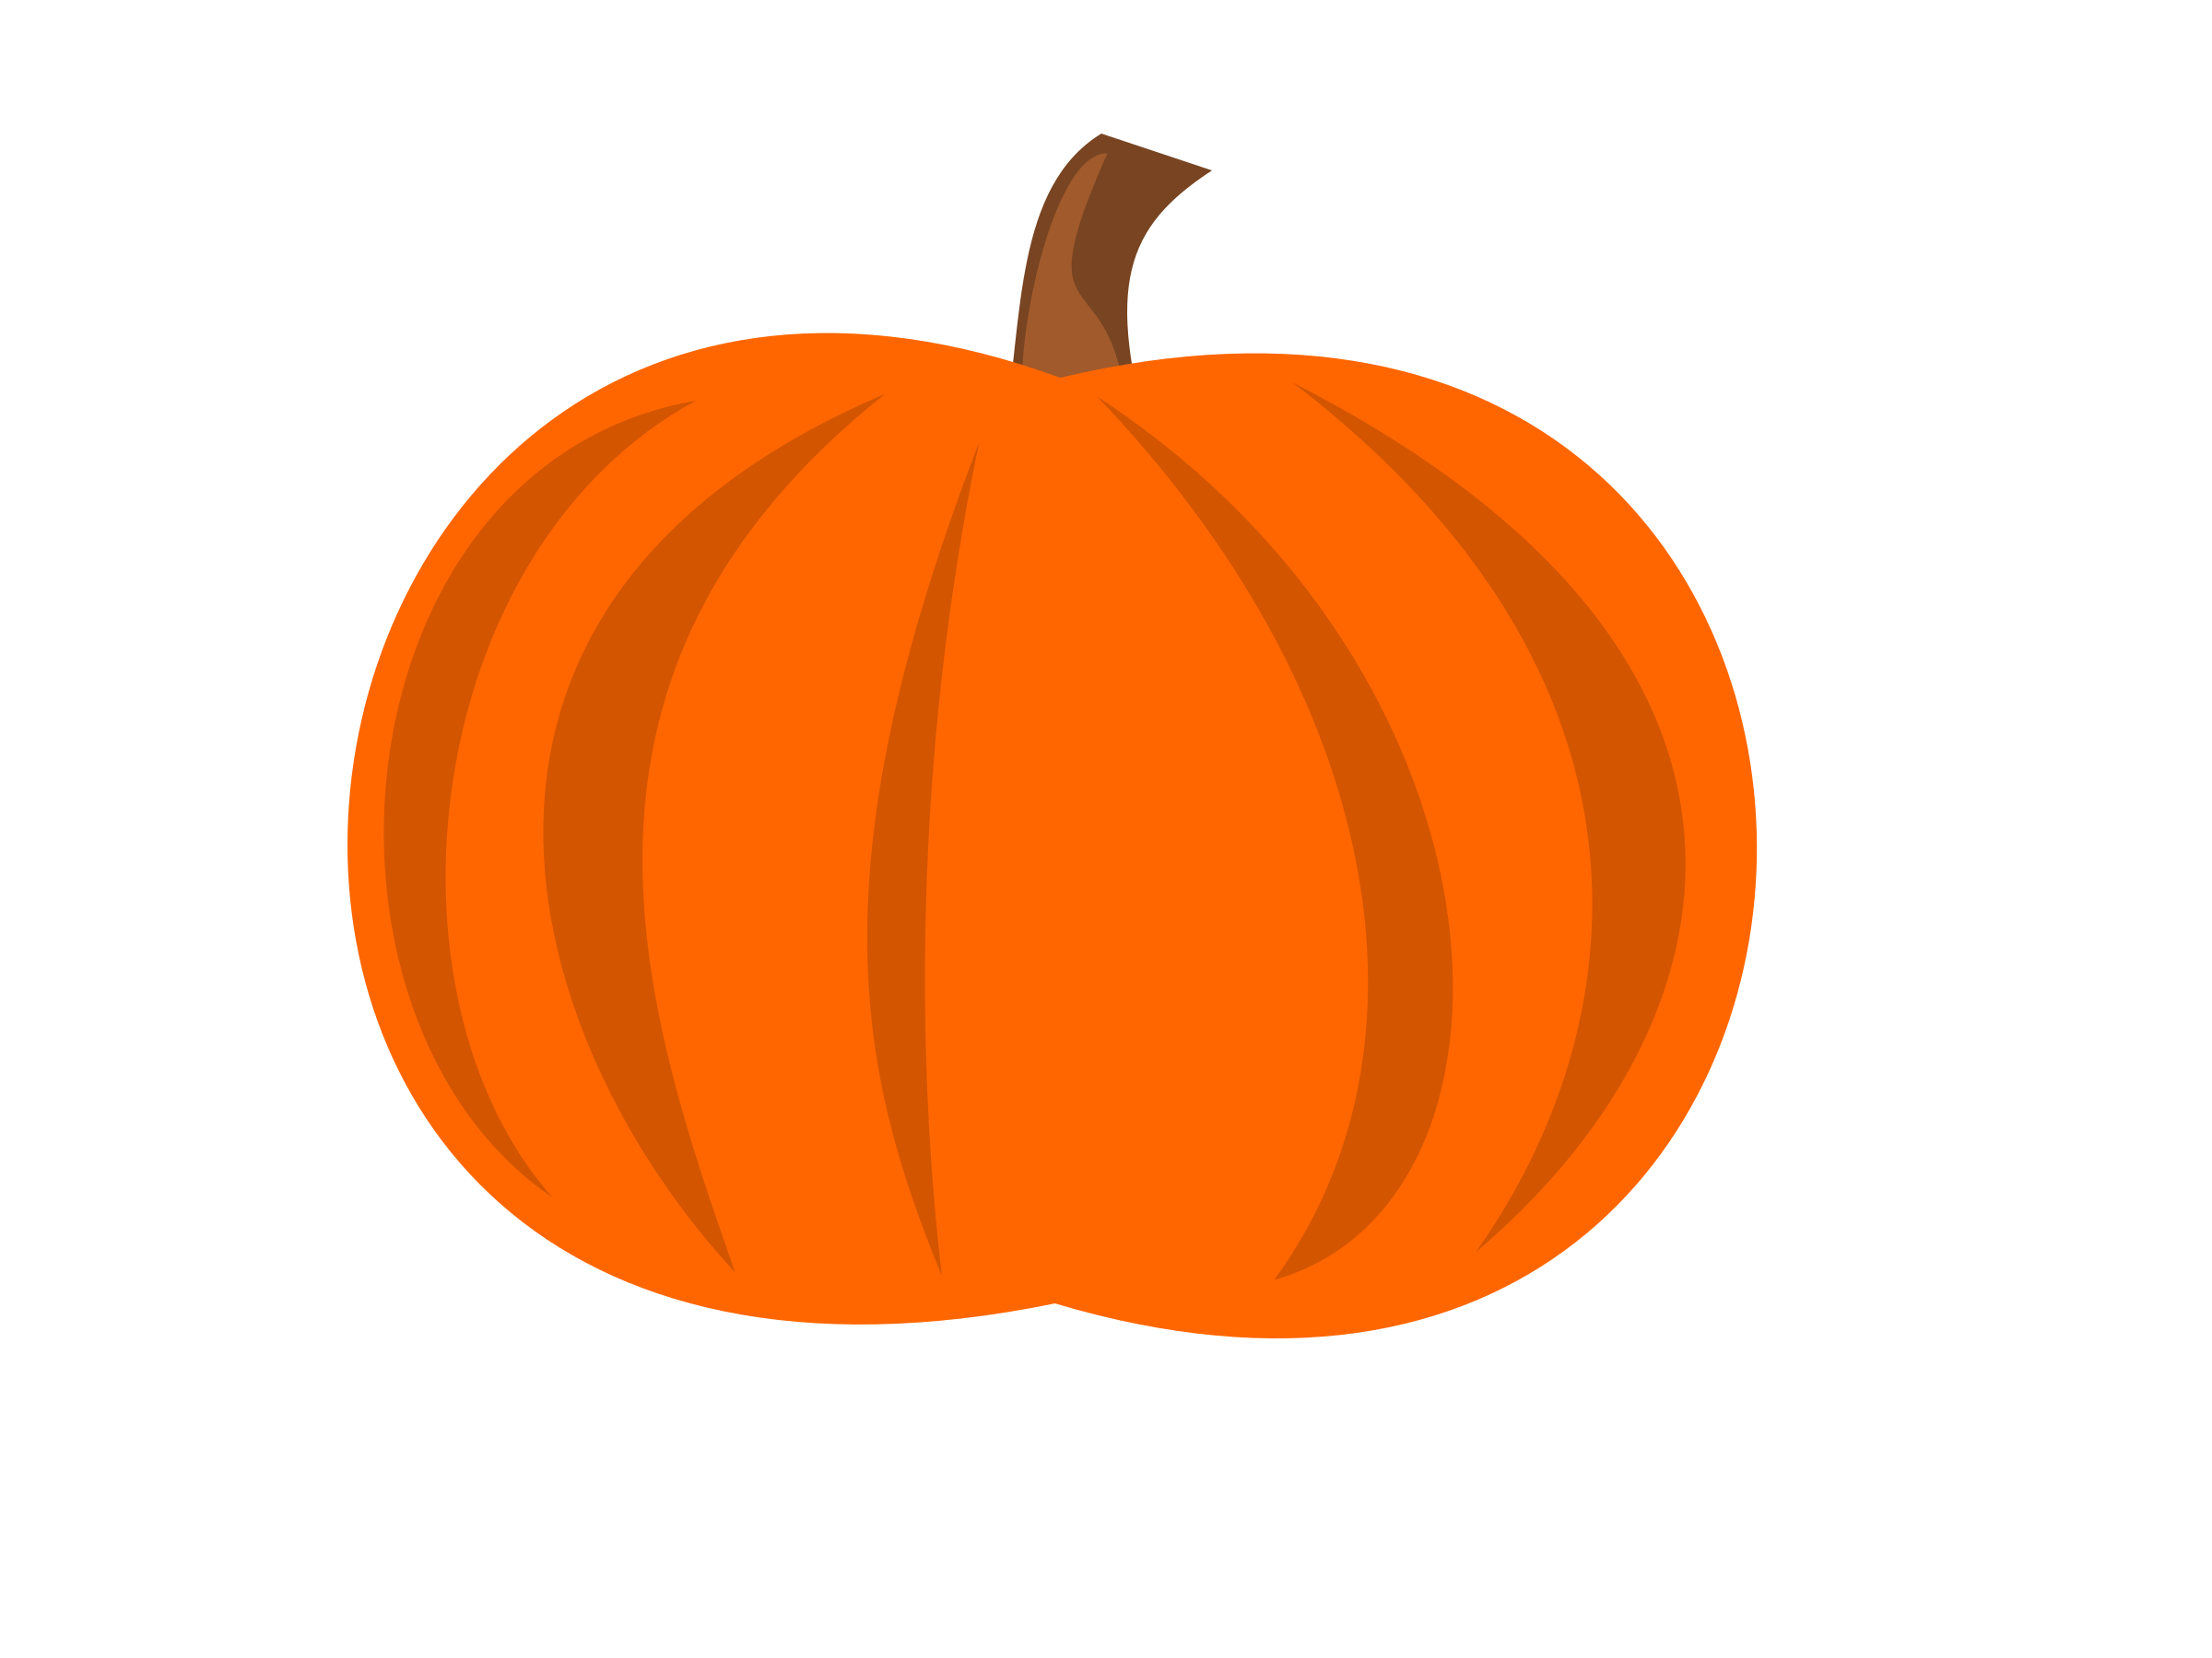

A “G”lorious week in Kindergarten as we met a new superkids! He is the beloved pet of the superkids, Golly! A perfect week for “G”randparents to visit our classroom!

**Please practice Hail Mary Prayer at home. I will be asking each student to recite it on February 16th as part of our religion curriculum**

Mrs. James☺

KINDER CHRONICLES October 6, 2017

**Reminders:**

PLEASE send in $5 in the red folder for our basket for the pancake breakfast, thank you to those who have already sent it in!

Please remember to sign in to Gradelink. Students were recently assessed on Memory Words!